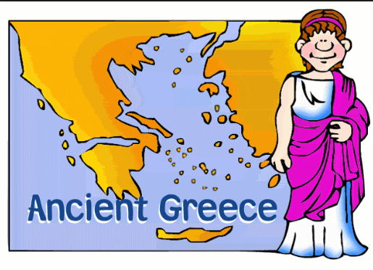

**History**

When the Ancient Greek people lived

Order events on a timeline

Battle of Marathon and the Trojan War

Ancient Greek Gods

Greek myths

Comparing modern day life to Ancient Greece

Looking at artefacts

Olympics

**RE** Sikhism

**Art/DT**

Topic based Art / DT

**PE**

Swimming Athletics

Tennis

**Music** Recorders

**PSHCE**

Healthy and Safer Lifestyles

Myself and My relationships

**ICT**

Animating E-Safety

**English**

Biography Writing

Story Writing

Report Writing

Poetry Writing

**Science**

Sound

Living Things and their habitats

**Maths**

Decimals Measurements Shape

Times tables Statistics Division

**Kite Class Topic**

**Summer 2019**