Wednesday 27th November 2019
Spellings – Scrabble Spellings
Work out how much each of your words are worth by counting the numbers on the Scrabble tiles.
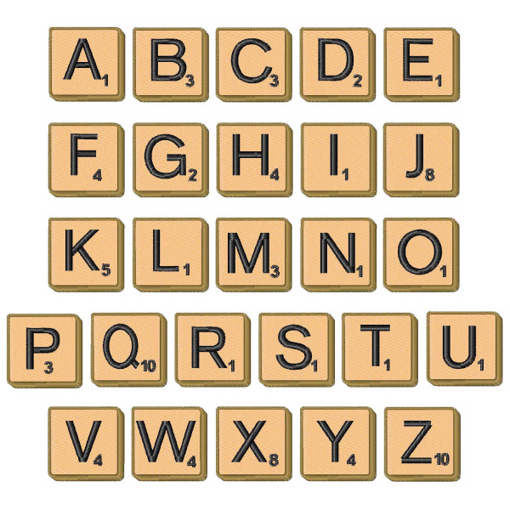
Word | Value
Example: people | 3 + 1 + 1 + 3 + 1 + 1 = 10
known
knocking
kneecap
knitting
knife
gnome
gnat
gnaw

