Tuesday 26th November 2019
be
Spellings – Dice Colouring
Roll the dice and colour your spelling word in the colour listed.
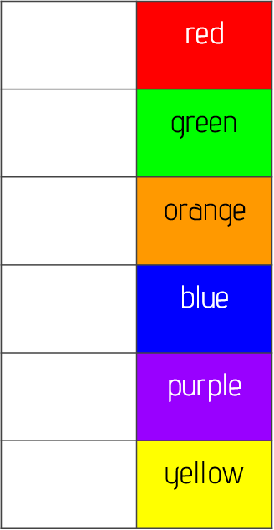
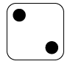
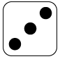
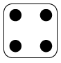
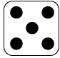
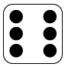
we
all
you
he
me
was
she

