Every fortnight you will be given three challenges, you will complete one task at school during our ‘Learning to Learn’ sessions and the other two you should work on at home.
Please attempt all three but how much time you spend on each challenge is up to you.
This will help support your work in class and give you a chance for more deep learning about the subjects we are studying.
You can choose how you lay the work out: it might be a large picture on card or a small booklet; it could be a power point presentation that you email to me through stars or a 3D model. It’s up to you.

- Writing – Write about somewhere exciting that you have been to. Include 3 conjunctions (and, but, or, because, so, if, when) in your writing.
- Maths – Log in to Mathletics and have a go at some of the activities.
- Creative – Find or write a poem ready to read to the rest of your class in 2 seeks time.
Fig. 1: The Parthenon

+0-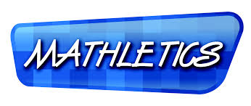m

