**PSHCE**

Myself and my relationships

Healthy and Safer Lifestyles

**A Contrasting Locality: developing country – human and physical aspects of geography.**

**Magic/Africa**

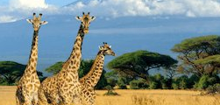

**Art/DT**

Patterns

Exploring African Art

**Spanish**

Greetings and numbers

**Maths**

Place Value Multiplication

Addition and Subtraction

**RE**

Judaism

**Geography - Africa**

* Recognise & understand that there are similarities & differences between places
* Know about the wider context of places
* Recognise knowledge of features about places beyond UK
* Recognise that people have differing quality of life in different locations & environments
* Explain how the locality is set within a wider geographical context

**Music**

Learning about different musicians and their music

**PE**

Games

**English**

Report Writing

Diary Writing

Instructional Writing

Descriptive Writing

Narrative Writing

**Science**

Digestive System

Teeth Electricity

**Kite Class Topic**

**Autumn 2020**

**ICT**

eSafety Programming

Programming