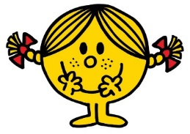
Topic Outline
Intake ‘17
First 2 Weeks of Term
Topic: The Mr Men visit Swift Class
Texts: Various Mr Men and Little Miss stories
Entry Point: The Mr Men are coming to Swift Class. They are excited to meet their new teachers Miss Jackson and Mrs Ward. Lots of changes have taken place since July and the classroom looks very different to what it did before. I wonder what exciting adventures lay ahead?
WOW Activity: Where’s Wally classroom treasure hunt
Topic Outcome: Swift Class promise and classroom expectations display.
English: During the first two weeks of term the children will be assessed and their initial targets identified. They will write a recount of their summer holiday, they will label a map of the classroom and they will write lists of ingredients needed for our cooking activity, as well as what is needed for doing maths, english or working on the carpet. They will also write captions to accompany pictures of the Mr Men’s visit to Swift Class.
Phonics: For the first two weeks of term all the children in Swift Class will be assessed and their phonic needs identified. They will learn games that will regularly feature in phonics lessons and be made aware of the structure of our sessions.
Guided Reading: Guided reading will start from week 3. All children will read with Miss Jackson and Mrs Ward at some point during the first week during their free read practice.
Maths: As well as assessing the children’s numerical abilities we will start our first math unit. We will look at place value, beginning with numbers to 10. The children will use their skills to represent each number in different ways both pictorially and using concrete resources.
The children will be introduced to ‘Magic 10’ and begin to learn the structure of these sessions.
The children will also begin daily number formation work.
Science: The children will start to look at the five senses and will carry out various simple tests including; taste testing sweet, bitter and savoury foods, using microscopes, testing how darkness affects sight, creating cup telephones and discussing how smell can affect taste.
Geography: We will briefly touch upon where the children live (village/town) with our Mr Men on the move activity. History and geography units will begin in week 3.
Art & Design: The children will create work using their hand prints as part of a whole school project. They will also be designing and creating their own Mr Men or Little Miss character.
As part of the Puffin class tea party, Swift class will be making Mr Happy and Little Miss Naughty biscuits.
Music: The children will begin the Charanga music unit – Hey You (pulse, rhythm and pitch).
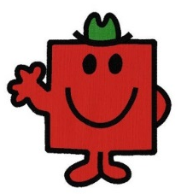
PE: The class will begin dance and fundamentals of movements units. In dance, children will learn to develop their movement through the theme of Mr Strong. Our fundamentals unit will focus on improving the children’s balance, movement and coordination skills, building on what they have learnt in reception last year.
RE: The class will begin the year by looking at birthdays.
PSHCE: This will be taught by Mrs Howard. Following our scheme of work, Swift class will start the year looking at beginning and belonging. Our literacy work will be closely linked to this.
Nature Detectives: Melwood sessions will begin just before half term.

Ideas:
