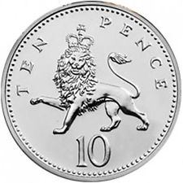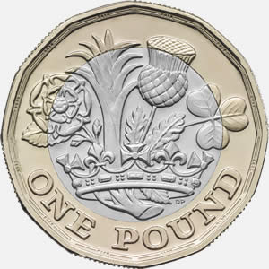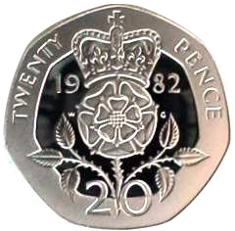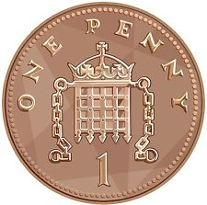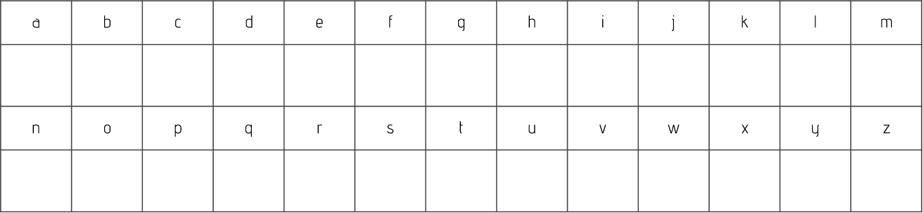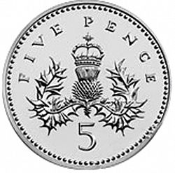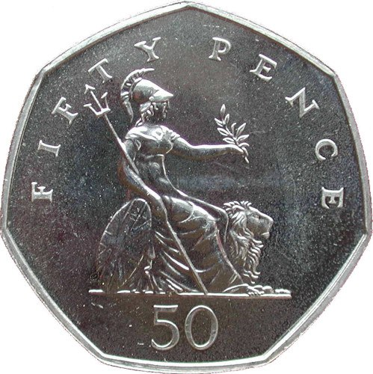Wednesday 4th December 2019

**Spelling Practice**

Work out how much your spellings are worth by adding the coins together.

|  |  |  |
| --- | --- | --- |
| **Word** | **Addition** | **Total** |
| Wren | 5 + 2 + 1 + 2 | 10p |
| known |  |  |
| knocking |  |  |
| kneecap |  |  |
| gnome |  |  |
| gnat |  |  |
| gnaw |  |  |
| knitting |  |  |
| knife |  |  |