About our Calculation Policy
The following calculation policy has been devised to meet requirements of the National Curriculum 2014 for the teaching and learning of mathematics It is also designed to give pupils a consistent progression of learning calculation methods across the school. Please note that early learning in number and calculation in Reception follows the ‘Development Matters’ EYFS document, and this calculation policy is designed to build on progressively from the content and methods established in the Early Years Foundation Stage.
Age stage expectations
The calculation policy is organised according to age stage expectations as set out in the National Curriculum 2014. It is vital that pupils are taught according to the stage that they are currently working at, being moved onto the next level when they are ready or working at a lower stage until they are secure enough to move on.
Providing a context for calculation
A problem solving approach helps to build children’s understanding of the purpose of calculation, and to help them recognise when to use certain operations and methods when faced with problems. It is important that any type of calculation is given a real life context. This must be a priority within calculation lessons.
Choosing a calculation method
Children need to be taught and encouraged to use the following processes in deciding what approach they will take to a calculation, to ensure they select the most appropriate method for the numbers involved… Can I do it in my head?
Could I use some jottings to help me?
Should I use a written method to work it out?
Early Years Multiply with concrete objects, arrays and pictorial representations.
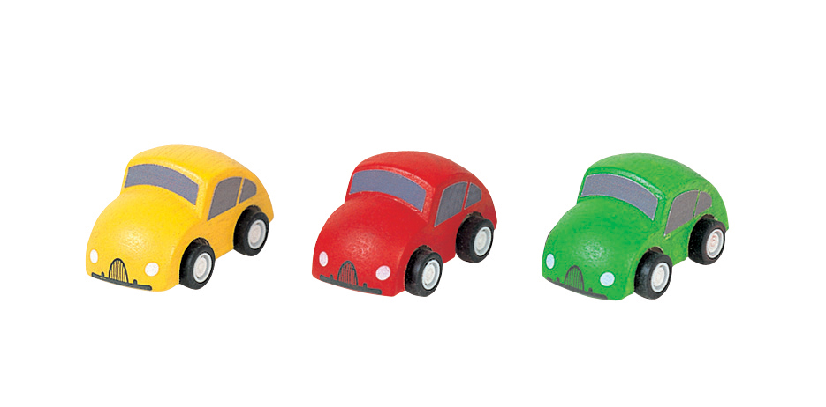
4 + 4 + 4
(Multiplication as repeated addition)

Key skills for multiplication in Early Years:
- Recognise numerals 1 to 20 and place them in order.
- Count actions or objects which cannot be moved.
- Record using marks that they can interpret and explain.
- Estimate how many objects they can see and check by counting.
- Record, using marks and pictures that they can interpret and explain.
- Help children to recognise that when a group of objects is separated in different ways the total is the same.
- Provide a wide range of number resources and encourage children to be creative in identifying and devising problems and solutions in all areas of learning.
- Help children to understand that five fingers on each hand make a total of ten fingers altogether, or that two rows of three eggs in the box make six eggs altogether.

Vocabulary: groups of, lots of, times, altogether, multiply, count

Year 1 Multiply with concrete objects, arrays and pictorial representations.
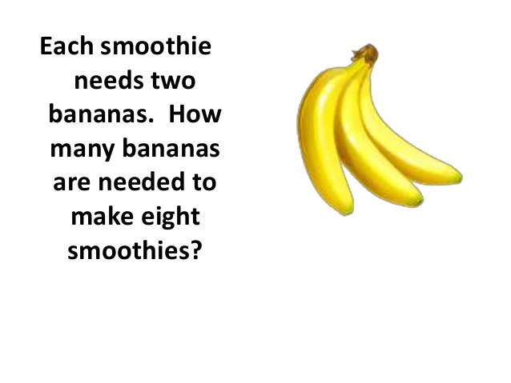
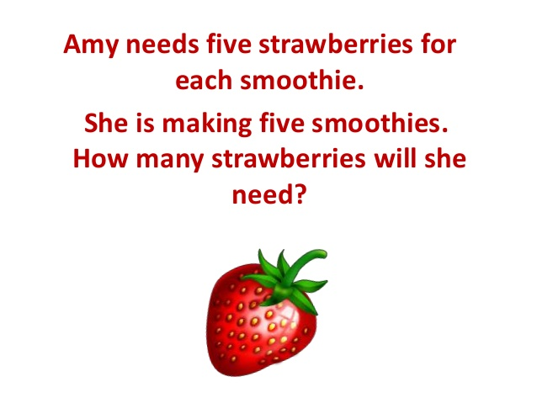

Children should have experience of counting equal group of objects in 2s, 5s and 10s.
Present practical problem solving activities involving counting equal sets or groups, as above.
Key skills for multiplication at Y1:
- Count in multiples of 2, 5 and 10.
- Solve one-step problems involving multiplication, by calculating the answer using concrete objects, pictorial representations and arrays with the support of the teacher.
- Make connections between arrays, number patterns, and counting in twos, fives and tens.
- Begin to understand doubling using concrete objects and pictorial representations.

Vocabulary: groups of, lots of, times, altogether, multiply, count, array

Year 2 Multiply using arrays and repeated addition (using at least 2s, 5s and 10s)
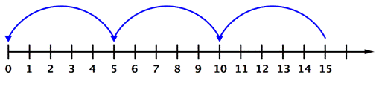
Repeated addition on a number line
Starting from 0 make equal jumps on a numberline to work out multiplication facts.
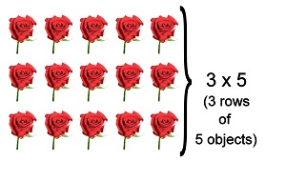
Write multiplication statements such as 3 x 5= 15
Use arrays to explore commutativity
5 x 3 = 3 + 3 + 3 + 3 + 3 = 15
3 x 5 = 5 + 5 + 5 = 15
Mental strategy – children should begin to recall multiplication facts for 2,5 and 10 times tables through practice in counting and understanding the operation.

Key skills for multiplication at Y2:
- Count in steps of 2, 3 and 5 from zero, and in 10s from any number.
- Recall and use multiplication facts from the 2, 5 and 10 multiplication tables, including recognising odds and evens.
- Write and calculate number statements using the x and = signs.
- Show that multiplication can be done in any order (commutative).
- Solve a range of problems using concrete objects, arrays, repeated addition, mental methods, and multiplication facts.
- Use a variety of language to discuss and describe multiplication.
Key vocabulary: groups of, lots of, times, altogether, multiply, count, array, multiplied by, repeated addition, column, row, commutative, sets of, equal groups, times as big as, once, twice, three times..., inverse
Year 2 Advice for staff
Use practical apparatus
Link multiplication to scaling:
Make a tower 3 times taller

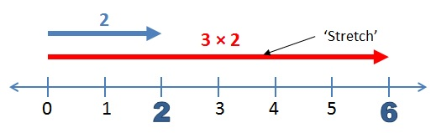

Year 3 Multiply 2-digits by a single digit number
The grid method for multiplying 2-digit by single-digits:
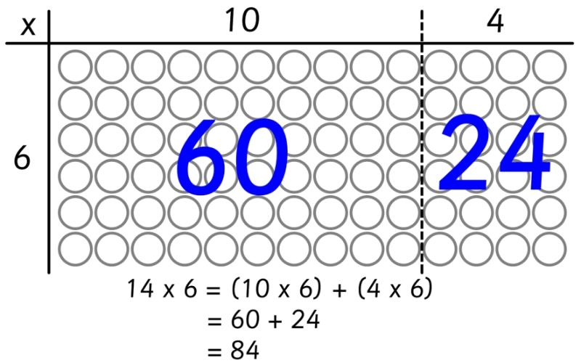
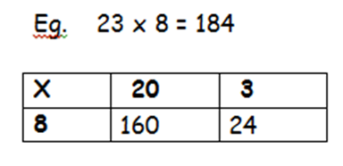
Link the grid method to an array
Key skills for multiplication at Y3:
- Recall and use multiplication facts for the 2, 3, 4, 5, 9 and 10 multiplication tables, and multiply multiples of 10.
- Write and calculate number statements using the multiplication tables they know, including 2-digit x single-digit, drawing upon mental methods, and progressing to reliable written methods.
- Solve multiplication problems, including missing number problems.
- Develop mental strategies using commutativity (e.g. 4 x 12 x 5 = 4 x 5 x 12 = 20 x 12 = 240)
- Solve simple problems in contexts, deciding which operations and methods to use.
- Develop efficient mental methods to solve a range of problems e.g using commutativity (4 × 12 × 5 = 4 × 5 × 12 = 20 × 12 = 240) and for missing number problems _ x 5 = 20, 3 x _ = 18, _ x _ = 32

Key vocabulary: groups of, lots of, times, array, altogether, multiply, count, multiplied by, repeated addition, column, row, commutative, sets of, equal groups, times, _times as big as, once, twice, three times..., inverse, partition, grid method, multiple, product, tens, units, value
Year 3 Advice for staff
To use the grid method children must be able to:
- Partition numbers into tens and units
- Multiply multiples of ten by a single digit (e.g. 20 x 4) using their knowledge of
multiplication facts and place value
- Recall and work out multiplication facts in the 2, 3, 4, 5, 8 and 10 times tables.
- Work out multiplication facts not known by repeated addition or other taught mental strategies (e.g. by commutative law, working out near multiples and adjusting, using doubling etc.) Strategies to support this are repeated addition using a number line, bead bars and arrays:

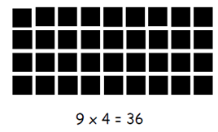
Introduce the grid method with children physically making an array to represent the calculation (e.g. make 8 lots of 23 with 10s and 1s place value counters), then translate this to grid method format

Year 4 Multiply 2 and 3-digits by a single digit, using all multiplication tables up to 12 x 12
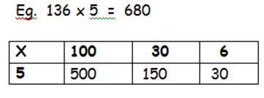
Developing the grid method
500
150
+ 30
680

Key skills for multiplication at Y4:
- Count in multiples of 6, 7, 8, 25 and 1000
- Recall multiplication facts for all multiplication up to 12 x 12.
- Recognise place value of digits in up to 4-digit numbers
- Use place value, known facts and derived facts to multiply mentally, e.g. multiply by 1, 10, 100, by 0, or to multiply 3 numbers.
- Use commutativity and other strategies mentally 3 x 6 = 6 x 3 , 2 x 6 x 5 = 10 x 6 , 39x7 = 30 x 7 + 9 x 7.
- Solve problems with increasingly complex multiplication in a range of contexts.
- Count in multiples of 6, 7, 9, 25 and 1000
- Recognise the place value of each digit in a four-digit number (thousands, hundreds, tens, and ones)

Key vocabulary: groups of, lots of, times, array, altogether, multiply, count, multiplied by, repeated addition, array, column, row, commutative, groups of, sets of, lots of, equal groups, times, multiply, times as big as, once, twice, three times... inverse, partition, grid method, multiple, product, tens, units, value, sets of
Year 4 Advice for staff

To use the developed grid method children should be able to:
- Approximate before they calculate, and make this a regular part of their calculating, going back to the approximation to check the reasonableness of their answer. e.g: 346 x 9 is approximately 350 x 10 = 3500
- Record an approximation to check the final answer against.
- Multiply multiples of ten and one hundred by a single-digit, using their multiplication table knowledge.
- Recall all times tables up to 12 x 12
Success stars for marking:

- Draw your grid first
- Partition numbers to multiply
- Reinforce the correct place value by reminding them the actual value is 5 hundreds add 3 hundreds, not 5 multiplied 3, for example. Consider counting and crossing out zeros to check.
- Add the totals in the boxes. (Encourage column addition to add efficiently.)
When confident move onto short multiplication (see Y5) if and when children are confident and accurate multiplying 2 and 3-digit numbers by a single digit this way, and are already confident in carrying for written addition.

Year 5 Multiply up to 4-digits by 1 or 2 digits.
Introducing column multiplication
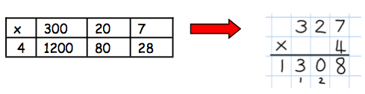
Introduce long multiplication
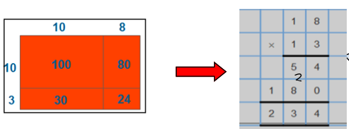
Key skills for multiplication at Y5:
- Solve problems where larger numbers are decomposed into their factors.
- Identify multiples and factors, using knowledge of multiplication tables to 12x12.
- Multiply and divide integers and decimals by 10, 100 and 1000
- Recognise and use square and cube numbers and their notation
- Solve problems involving combinations of operations, choosing and using calculations and methods appropriately.
Key vocabulary: groups of, lots of, times, array, altogether, multiply, count, multiplied by, repeated addition, column, row, commutative, sets of, equal groups, _times as big as, once, twice, three times..., inverse, partition, grid method, total, multiple, product, tens, units, value, sets of, square, factor, integer, decimal, short/long multiplication, carry
Year 5 Advice for staff

Short multiplication for multiplying by a single digit
Introduce by comparing a grid method calculation to a short multiplication method to see how the steps are related, but notice how there are fewer steps involved in the column method
Pupils could be asked to work out a given calculation using the grid, and then compare it to your column method. What are the similarities and differences? Unpick the steps and show how it reduces the steps.
Introduce long multiplication for multiplying by 2 digits
18 x 3 on the first row (8x3 = 24, carrying the 2 for twenty, then 1x3). 18 x 10 on the 2nd row. Put a zero in units first, then 8x1 & 1x1.

The grid could be used to introduce long multiplication, as the relationship can be seen in the answers in each row.
Moving towards more complex numbers
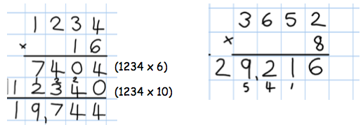
Year 6 Short and long multiplication as in Y5, and multiply decimals with up to 2 d.p. by a single digit.
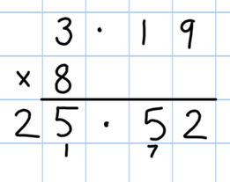

Key skills for multiplication at Y6:
- Recall multiplication facts for all times tables up to 12 x 12 (as Y4 and Y5).
- Multiply multi-digit numbers, up to 4-digit x 2-digit using long multiplication.
- Perform mental calculations with mixed operations and large numbers.
- Solve multi-step problems in a range of contexts, choosing appropriate combinations of operations and methods.
- Estimate answers using round and approximation and determine levels of accuracy.
- Round any integer to a required degree of accuracy.
Key vocabulary: groups of, lots of, times, array, altogether, multiply, count, multiplied by, repeated addition, array, column, row, commutative, sets of, equal groups, times as big as, once, twice, three times... partition, grid method, total, multiple, product, inverse, square, factor, integer, decimal, short / long multiplication, carry, tenths, hundredths, decimal

Year 6 Advice for staff

Children should now be able to:
- Use short multiplication (see Y5) to multiply numbers with more than 4-digits by a single digit; to multiply money and measures, and to multiply decimals with up to 2d.p. by a single digit.
- Use long multiplication (see Y5) to multiply numbers with at least 4 digits by a 2-digit number.

Remember to:

- Use rounding and place value to make approximations before calculating and use these to check answers against.
- Line up the decimal points in the question and the answer.
- Remind children that the single digit belongs in the units column.
- This works well for multiplying money (£/p) and other measures.

