Every fortnight you will be given three challenges, you will complete one task at school during our ‘Learning to Learn’ sessions and the other two you should work on at home.
Please attempt all three but how much time you spend on each challenge is up to you.
This will help support your work in class and give you a chance for more deep learning about the subjects we are studying.
You can choose how you lay the work out: it might be a large picture on card or a small booklet; it could be a power point presentation that you email to me through stars or a 3D model. It’s up to you.

- Maths – Practice your 3 times tables. Write word problems for 3 calculations.
e.g.: 4x3=12
I have four bags of 3 apples, how many apples do I have all together?

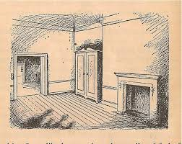
- Creative – Imagine you have found a wardrobe in an empty room, just like Lucy in the Lion the Witch and the Wardrobe. Draw a picture of what you found inside your wardrobe.

- Writing – Write a story titled “What I found the wardrobe.”

