Gaming
Cambridgeshire Police have expressed their concerns about the risk to young people through the use of online games such as Minecraft and World of Warcraft:
- the game is used as a contact point – unsuitable people play the game, befriend children and establish a relationship before moving to further contact outside the game.
- opportunities for children to be targeted is thought to be high
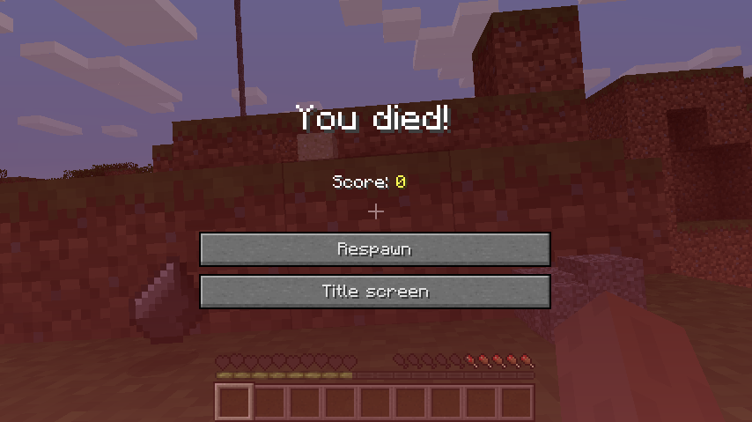
- both male and female children are being targeted

What is Minecraft?
Minecraft is typical of the kind of game that poses a risk to young people. It is a survival game with a Lego like look and feel. Players spend most of their time roaming around, building/mining structures and ‘contraptions’, and collecting anything they can find. The game option moves between daytime when players are safe and night-time when there are ‘dangers’, and so it is important to use daylight hours to build a safe place to stay. As a player you have a choice to play online. Players link into communities and share creations, discuss the mechanics of the game etc.

What‘s the risk?
While players can stay safe if they play on a locally downloaded copy, Minecraft in particular is problematic in that it can be hosted on public and private servers and so the ease with which a player can find themselves participating online poses a risk. On a wireless enabled device, the default option is set to connect to available servers. This allows players to easily chat with one another during game play, view creations etc and where they may be subject to unwanted attention.
Like most similar games, there is also the risk of addiction. Because there is a creative element, a player could spend hours working on their structures within the game and roaming around exploring. Children have been known to become ‘distraught’ after spending time over a number of days and weeks creating their Minecraft environment to have it destroyed in an instant by another game player.

What Can I do?
Parents should be aware of age ratings and watch game playing as often as possible to check for potentially scary features, child-friendly graphics and inappropriate language or behaviour used within the game.
- You might sometimes play the game with their child/ren.
- Try to place the online activity in a public part of the house where activity can be seen and heard and not in bedrooms.
- Within some games it is possible to install a child-friendly graphics option or set a menu option to a ‘Peaceful’ difficulty level.
- In Minecraft it is possible to access the menu and view a recent history of servers accessed.
- Some servers are more child friendly than others - check them out/block if necessary.
- Establish some time limits to game playing and suggest activities when game time is finished
- Talk regularly about the on screen gaming experience with your child/ren.

Useful information about Minecraft from other parents:
• http://parenting.kidspot.com.au/what-is-minecraft/#.UwDlr4U0_gU
• http://parentsguidetominecraft.blogspot.co.uk/
• http://erikafinn.com/a-parents-guide-to-minecraft/

Wii: http://www.nintendo.com/consumer/systems/wii/en_na/settingsParentalControls.jsp
XBox: http://www.xbox.com/en-GB/support/xbox360/familysettings/consolefamilysettings.htm
Nintendo DS: http://www.nintendo.com/consumer/systems/ds/dsprivacy.jsp
Sony Playstation: http://www.us.playstation.com/support
More general information about reporting inappropriate online activity…..
• Has someone acted inappropriately towards you online, or to a child or young person you know? It may be inappropriate chat, being asked to do something that makes you feel uncomfortable or someone being insistent on meeting up. You can report it to http://www.ceop.police.uk/safety-centre/
• Childnet International produce a range of useful leaflets, videos and other materials for parents, teachers and children http://www.childnet.com/resources

