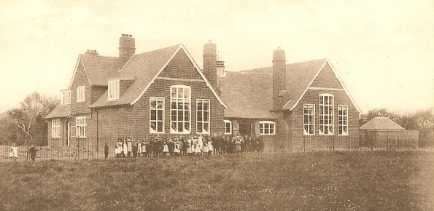
Music
Composition and performance skills using recorders

RE
Representations of Jesus

Science
Electricity: Use apparatus to construct a series circuit, use symbols to represent circuit diagrams.

Hawk Class
Year 6, Spring 1
Meldreth Through Time

Art
A study of local artists

PE
Gymnastics
Dance
PSHE
Myself and my emotions.
Financial capability.
MFL- Spanish
Weekly lesson with Mrs Millington

Geography/history
- Looking at physical and human geography of Meldreth and the surrounding areas.
- Aspects of history from 1800 to the present day, with a focus on Meldreth and the surrounding areas.

Maths objectives for this half term (geometry, statistics):
- Draw 2D shapes using given dimensions and angles.
- Recognise, describe and build simple 3D shapes, including making nets.
- Compare and classify geometric shapes, based on their properties and sizes.
- Find unknown angles in any triangles, quadrilaterals and regular polygons.
- Illustrate and name parts of circles, including radius, diameter and circumference and know that diameter is twice the radius.
- Recognise angles where they meet at a point, are on a straight line, or are vertically opposite, and find missing angles.
- Describe positions on the full co-ordinate grid (all four quadrants).
- Draw and translate simple shapes on the co-ordinate plane, and reflect them in the axes.
- Interpret and construct pie charts and line graphs and use these to solve problems.
- Calculate and interpret the mean as an average.

Grammar knowledge for this half term:
Revision of Year 5 objectives:
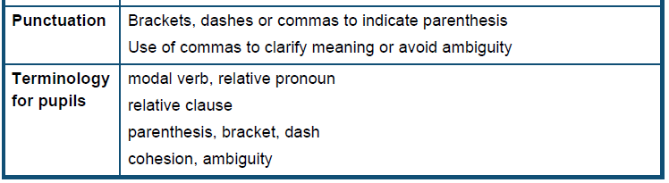
New Year 6 objectives:
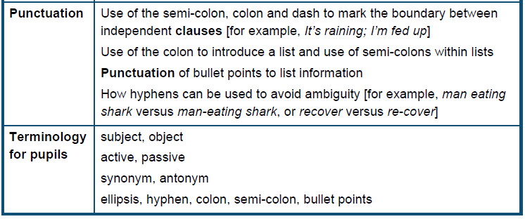

Pupil’s independent writing work will begin to be assessed by Miss Hill and other members of staff this half term. For your information, the writing assessment criteria is attached:
