**ICT**

eSafety

Programming

**Art/DT**

Topic based art / DT

Making Volcanoes

**Spanish** Revision

**RE /PSHE** Buddhism

Good and evil

**Music** Music through the ages

**PE**

OAA

Tennis

**Geography**

**Geography: Climate Change**

* Describe how people have been affected by changes in the environment
* Explore weather patterns around the world
* Use terms such as contour, height, valley, erosion, deposition, transportation, headland, volcanoes, earthquakes

**History: describe a local history study**

**Geography: local**

* Describe human features of UK regions, cities and/or counties
* Explain about key natural resources in the locality
* Understand the effect of landscape features on the development of the locality
* Communicate findings in appropriate ways
* Measure straight line distances, use 6 figure grid references, make plans & maps using symbols & keys
* Plan the steps for an enquiry

**PSHCE**

Me and my relationships

Healthy and safer lifestyles

**Science**

**Materials:** solids, liquids, gases including water cycle.

**Living things and their habitats**

**The World Around Us**

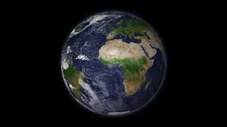

**Maths**

Revision Decimals Money

Measurement Time

**English**

Report Writing

Descriptive Writing

Biography Writing

Non-negotiables

Poetry

**Kite Class Topic**

**Summer 2021**