This curriculum provides a starting block for schools to embark on teaching an effective and engaging curriculum. In the recent After the reboot: computing education in UK schools (2018), it was stated that in order for children to leave school and “to embark on successful professional careers and to become astute and responsible citizens...children should begin to study computing at the earliest age possible”.

The resources are drawn mostly from the Purple Mash and Project Evolve units of work however there is a termly opportunity for students to link computing with another subject and create a piece of work more personalised to their individual experience as a student of Meldreth Primary. The planning has been divided into three sections: digital literacy, which incorporates E-Safety refreshed at the beginning of every term; computer science; and information technology.

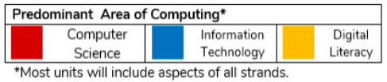

 | Autumn 1 | Autumn 2 | Spring 1 | Spring 2 | Summer 1 | Summer 2
Year 1 | E-safety: Project Evolve  Exploring Purple Mash  Grouping & Sorting | 2Count: Pictograms  2DIY: Lego Builders | E-safety: Project Evolve  2Go: Maze Explorers | 2Create A Story: Animated Story Books | E-safety: Project Evolve  2Code: Coding | 2Calculate: Spreadsheets  Technology Outside School
Year 2 | E-safety: Project Evolve  2Calculate: Spreadsheets | 2Code: Coding | E-safety:  Project Evolve  2Question/2Investiage: Questioning | Effective Searching  2Sequence: Making Music | E-safety: Project Evolve  2Paint A Picture: Creating Pictures | Presenting Ideas
Year 3 | E-safety: Project Evolve  2Calculate: Spreadsheets | 2Code: Coding | E-safety: Project Evolve  2Type: Touch Typing | 2Email: Email & Email Safety | E-safety: Project Evolve  2Question: Branching Databases  2Simulate: Simulations | 2Graph: Graphing  Google Slides: Presenting
Year 4 | E-safety: Project Evolve  2Calculate: Spreadsheets | 2Code: Coding | E-safety: Project Evolve  2Logo: Logo | Writing for different audiences | E-safety: Project Evolve  2Animate: Animation  Hardware Investigators | Effective Searching  Busy Beats: Making Music
Year 5 | E-safety: Project Evolve  2Calculate: Spreadsheets | 2Code: Coding | E-safety: Project Evolve  2Investigate: Databases | 2Design & Make: 3D Modelling  2Connect: Concept Maps | E-safety: Project Evolve  2DIY 3D: Game Creator | Google Docs: Word Processing
Year 6 | E-safety: Project Evolve  2Calculate: Spreadsheets | 2Code: Coding | E-safety: Project Evolve  2Blog: Blogging | 2Code/2Connect: Text Adventures  Networks | E-safety: Project Evolve  2Quiz: Quizzing | 2Code: Understanding Binary  Google Sheets: Spreadsheets

Termly Cross-Curricular Use of Computing:

 | Autumn Term | Spring Term | Summer Term
Year 1 | Maths – build on grouping and sorting skills by using the shape colour group sorting application on ipads. | English: Rewrite a Fairy Tale using the animated story book app | PE (OAA) – guiding a robot (blindfolded child) around school focusing on giving simple instructions for them to follow. Thinking of possible consequences of giving an incorrect instruction.
Year 2 | English: Typing up letter to Santa | Music: Dragon theme tunes  Maths: Making block diagrams | Art: Creating pictures inspired by artists studied
Year 3 | Topic: Type a post-card using Purple Mash as a summary of our topic.  RE: Use iPads to record videos re-telling a religious story. | Maths: Collect data and use Purple Mash 2Graph to create bar and pie charts. | English: Research countries of the world.
Year 4 | Topic: Research on the area of topic we are learning about  English: Type up stories  Maths: Make statistics charts on Purple Mash to go with their Christmas advert debate - create a range of programs, systems and content that accomplish given goals, including collecting, analysing, evaluating and presenting data and information | English: Type up their newspaper articles all about natural disasters or climate change. | Topic: Research on the area of topic we are learning about  Topic: Digital
Year 5 | Art: Use Ipads to take pictures showcasing perspective then upload and edit | English: Type up and format Alma newspaper report in Google Docs with columns, images and captions | Maths: Collect data & use Google Sheets to present in a variety of ways, e.g. line graph, pie chart
Year 6 | Art: Creating and designing kites using a variety of media (to include designing on PurpleMash alongside sketching, painting etc.). | PSHE: Use spreadsheets to create a budget (Financial Capability unit).  Science: Researching and presenting using Google Slides (Famous Scientists unit). | History: Researching a variety of sources to independently research and present an aspect of the history topic that they find interesting.  PSHE: Designing and formatting leaflets about moving to secondary school (Managing Change unit).

Computing in EYFS:

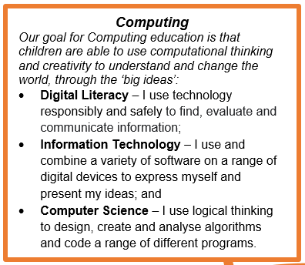
Early Years Foundation Stage will explore a range of different cause & effect ICT resources and access Ipads, using programmes related to the child-led topics within the EYFS framework. Their learning will be centred around play-based, unplugged activities that focus on building children’s listening skills, curiosity, creativity and problem solving. They will use suitable age-related Purple Mash programmes to support their learning. They will use physical computing during role-play and have access to items such as Bee-bots as an early introduction to coding and programming and tablets and cameras to explore the world around them.

