Maths Revision – Measurement

**E Measure**

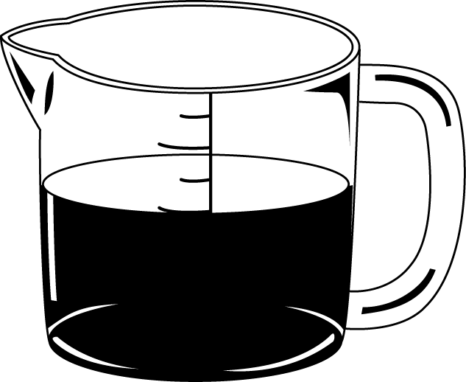

**19.** The cup contains 240 ml of liquid.

 The jug contains 500 ml of liquid.

How much **more** liquid is in the jug?

|  |
| --- |
| **ml** |





1 mark (3:19)

**20.** Here is a rectangle on a centimetre grid.

|  |  |  |  |  |  |  |  |  |
| --- | --- | --- | --- | --- | --- | --- | --- | --- |
|  |  |  |  |  |  |  |  |  |
|  |  | | | | | | |  |
|  |  |
|  |  |
|  |  |  |  |  |  |  |  |  |



cm

 What is the perimeter of the rectangle?

1 mark (3:20)

**21.** Judith has £5.

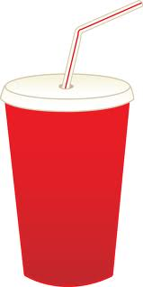

She buys a burger, fries and a cola.

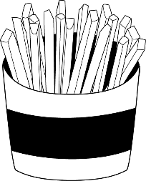

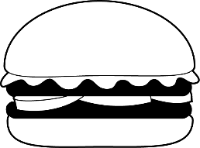

Cola

80p

Fries

90p

Burger

£2

How much **change** should she have?

Show your working. You may get a mark.



£**____ and ____**p



2 marks (3:21)

**22a.** Draw the minute hand so that the **b.** What time does this clock show?

clock shows **ten minutes past nine.**

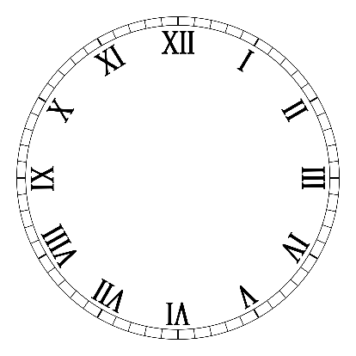 **A B**

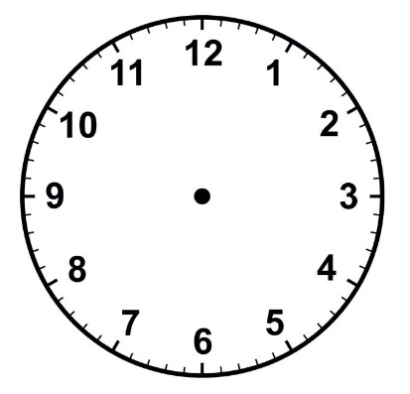



ten minutes past nine



2 marks (3:22)

**23.** About how long does it take for a full kettle to boil?

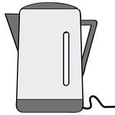 Tick (**✓)** the best **estimate**.



about 40 seconds about 4 minutes

 about 40 minutes about 4 hours

1 mark (3:23)

**24.** Draw **all** the missing lines.

months in a year 365

days in September 30

days in a year 24

weeks in a year 12

 hours in day 52

2 marks (3:24)

**E Measure**

**19.** Ethan and Jessica measured their **heights** using a tape measure. Their **heights** are below.

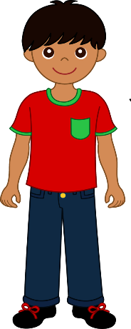

Ethan’s height Jessica’s height

1m 9cm 119cm

Who is the **tallest**?



1 mark (3:20)

**20.** What is the **perimeter** of this **square**?

7cm



**cm**



1 mark (3:20)

**21.** At the shop Connor buys 2 drink cartons and an ice lolly.

He pays with two £2 coins? How much change will Connor receive?

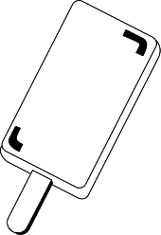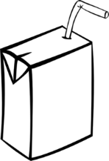

£1

60p

Show your working. You may get a mark.



£**____ and ____**p



2 marks (3:21)

**22a.** Write the time below as it would **b.** Write the time below as it would

appear on a **24-hour clock.** appear on a **12-hour clock.**

You **must** **circle** if it is **a.m.** or **p.m.**

**A B**

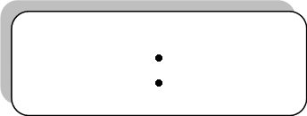

12 hour clock

12 hour clock

am

47 pm

am

12

pm



24 hour clock

24 hour clock

19

05



2 marks (3:22)

**23.** Write a, b, c and d to sort these periods of time from **shortest** to **longest**.

1

2

a. 80 minutes b. 1 hours c. 95 minutes d. An hour & a quarter





shortest longest

1 mark (3:23)

**24.** Draw **all** the missing lines.

days in a week 365

seconds in a minute 28

days in a year 60

days in February 7

 days in a leap year 366

2 marks (3:24)

**E Measure**

**19.** Ethan and Jessica weighed themselves on a set of scales. Their weights are below.

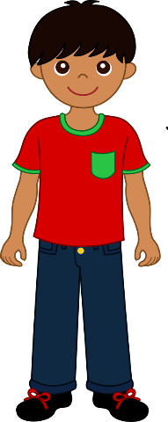

Ethan’s weight = 25kg Jessica’s weight = 24000g

 Who weighs the **most**?



1 mark (3:20)

**20.** What is the **perimeter** of this shape?

|  |  |  |  |  |  |  |  |  |
| --- | --- | --- | --- | --- | --- | --- | --- | --- |
|  |  |  |  |  |  |  |  |  |
|  |  |  |  |  |  |  |  |  |
|  |  |  |  |  |  |  |  |  |
|  |  |  |  |  |  |  |  |  |
|  |  |  |  |  |  |  |  |  |

 1cm

cm

1 mark (3:20)

**21.** Rebecca has £3.

At the shop she buys a drink for 90p and a packet of crisps for 50p.

How much **change** will Rebecca have left?



£**____ and ____**p



2 marks (3:21)

**22.** Draw the **minute** **hands** on these clocks to show the times written below.

 **A B**



Twenty minutes past two.

Ten minutes to eight



2 marks (3:22)

**23.** Write a, b, c and d to sort these periods of time from **shortest** to **longest**.

a. 25 minutes b. 120 seconds c. Half an hour d. 1 minute





shortest longest

1 mark (3:23)

**24.** **a)** How many **days** are there in a **year**?

days

 **b)** How many **days** are there in a **leap year**?

days



2 marks (3:24)